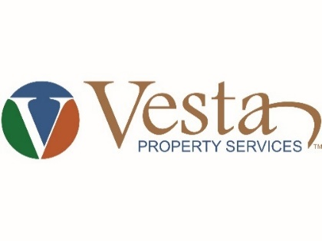
27180 Bay Landing Drive, Suite 4
Bonita Springs, FL 34135
239-947-4552, (f) 239-495-1518
jtanigawa@vestapropertyservices.com
www.VestaPropertyServices.com

WINDSOR PLACE AT BERKSHIRE LAKES
CONDOMINIUM ASSOCIATION, INC.
Board of Directors Meeting

DATE: Wednesday October 13, 2021
TIME: 7:00 p.m.
LOCATION: Conference Call
Call-In Number: 866-705-2554
Listen-In Passcode: 4841597
Any questions for the meeting please email wsanford.ctr@oasnaples.com or text to 239-398-9525 prior to or during the meeting. They will be reviewed at the end of the meeting.

AGENDA
- Call to order and determine a Quorum
- Proof of Notice
- Disposal of the Previous Meeting Minutes
- President’s Report
- Vice President’s Report
- Director’s Report
- Treasurer’s Report
- Manager’s Report
- Committee Reports
  - Leases and Sales
- Old Business
  - Maintenance – Cont.
- New Business
  - VESTA / CAM Information
  - 2022 Budget
  - Holiday’s Decorating Invitation
- Open Forum
- Adjournment

